We do not have req.cookie header initially

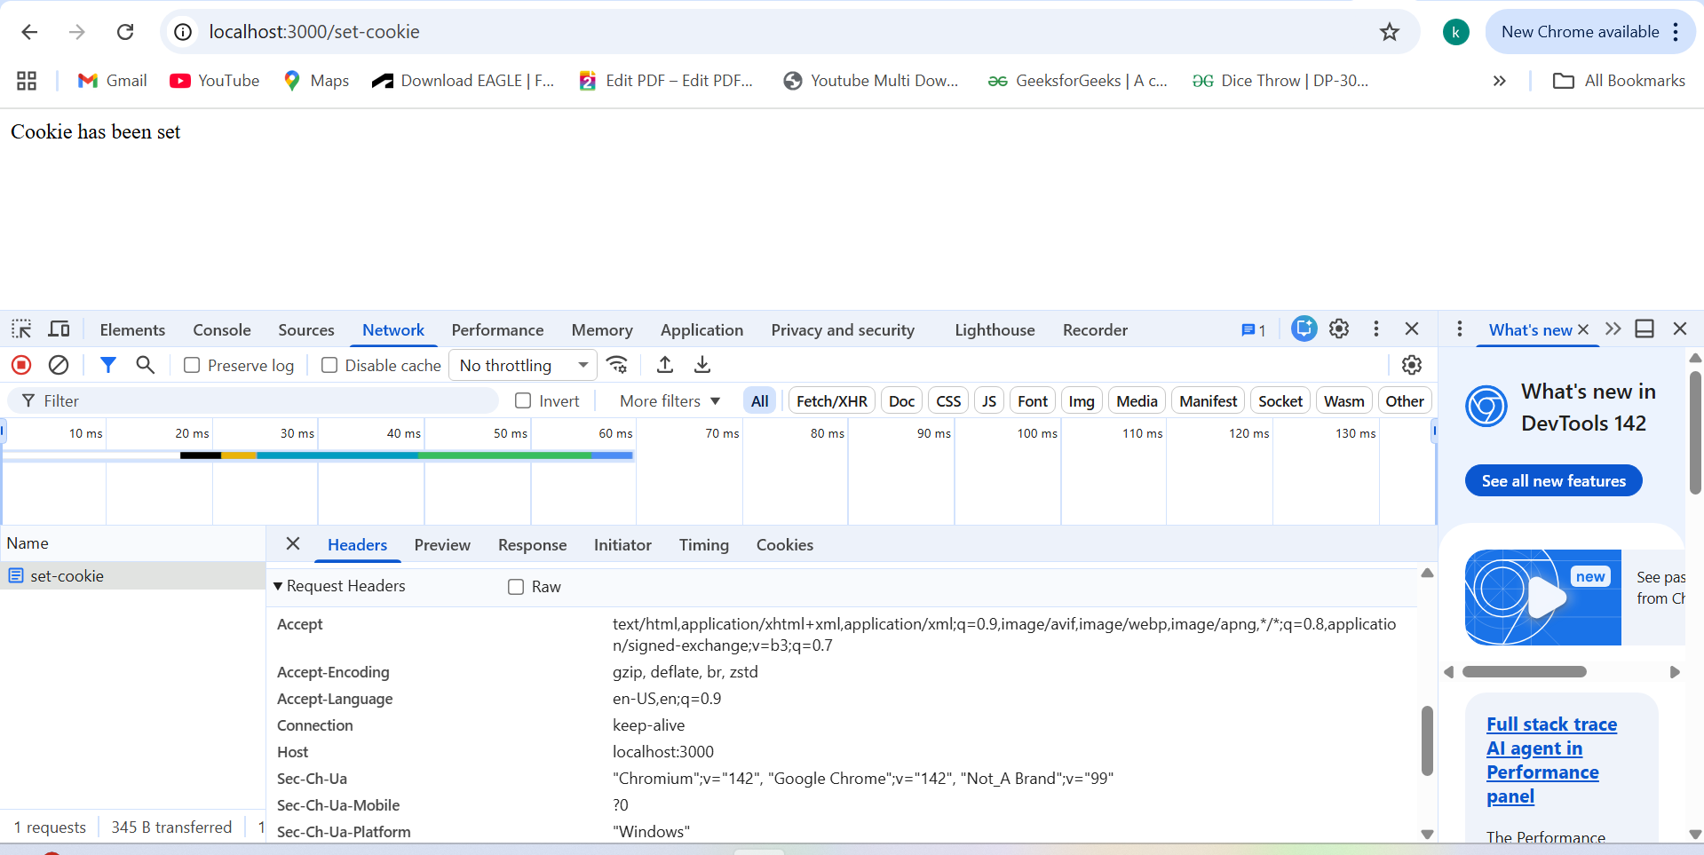

But behind the scene we are setting using res.cookie

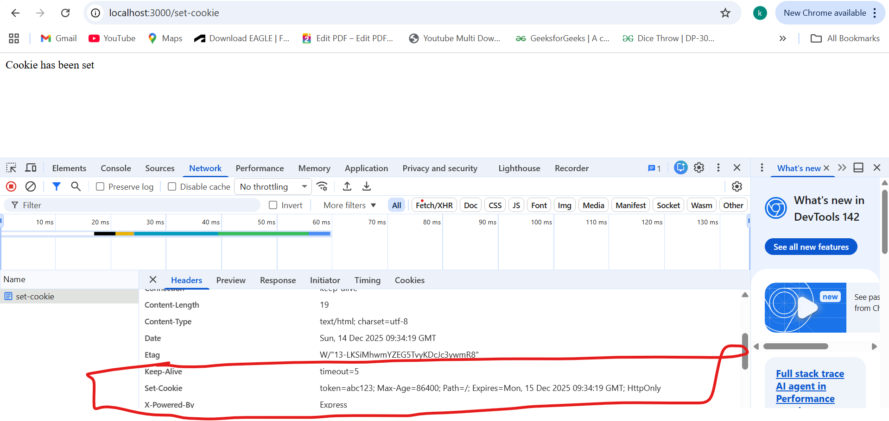

Next time if we are making api call we do have this header populated 